جامعة المنوفية
كلية الحاسبات والمعلومات
2026-2027
Menofyia University
System Analysis & design Project
second year
2026-2027

No. | Name | Section
1 | Youssef Mohamed Osman
2 | Arafa
3 | Mahmoud
4 | Marwan
5 | Ameer
6

Small Business Invoice Payment Tracking System

Planning (Project Plan)

Project Identification
Project Name:
Small Business Invoice Payment Tracking System
Current Problem:
1- Difficulty tracking unpaid invoices and payment deadlines.
2- Invoices and payment records may be disorganized.
3- Difficulty calculating the total paid and unpaid amounts.
4- Possibility of losing or entering payment information incorrectly.

Description about project:
● The system can easily track invoices and payments by entering the invoice number or customer name. It enables the user to record payments and check whether an invoice is paid, unpaid, or partially paid. The system organizes invoices and their payment details, helps calculate the total paid and unpaid amounts, and makes it easier to identify overdue invoices. It saves time and effort, reduces errors, and helps prevent the loss of invoice and payment records.

System Request
System Request—library System
Project Sponsor: | Youssef
Business Need: | 1- Reduce errors in invoice and payment records.  2- Track unpaid invoices and payment deadlines.  3- Keep invoice information organized.  4- Make payment information easy to access.
Business Requirements: | 1- Add, update, and delete invoice records.  2- Record customer payments.  3- Display paid, unpaid, and overdue invoices.  4- Calculate total paid and unpaid amounts.
Business Value: | 1- Saving time.  2- Reducing errors.  3- Improving payment tracking.  4- Saving effort and organizing records.
Special Issues or Constraints: | 1- Protect customer and payment information.  2- Keep invoice and payment records accurate and up to date.

Feasibility Analysis
Technical Feasibility
- We need to design the system using HTML, CSS, and JavaScript.
- We need development software such as Visual Studio Code.
- The system should work online when connected to the internet.
- The system should be accessible through web browsers on computers and mobile devices.

Economic Feasibility
- The benefits of this project will be acceptable.
- The system will reduce the time and effort needed to track invoices and payments.
- The main cost will be developing and maintaining the system.
- The development cost will be relatively low because the system can be built using available tools and software.

Organizational Feasibility
Organizational Feasibility Analysis includes the assessment of:
1. Management prowess: The business owner or manager will be responsible for managing the system and ensuring that invoices and payments are recorded correctly.
2. Resource sufficiency: The system will require a developer, a computer, internet access, and employees who can enter and update invoice and payment information.

Time Estimation

 | Planning | Analysis | Design | Implementation
Standard percentages | 14% | 21% | 34% | 31%
Estimated time based on planning time | Actual: 10 days | 15 days | 24 days | 21 days

Tasks Identification
System Request | Name of Task
2/10/2026 | Start Date
16/10/2026 | End Date
Youssef | Person assigned to task
High | Priority
Microsoft word | Resources Needed
4 hours | Estimated Time
2hours | Actual Time

Feasibility Study | Name of Task
10/10/2026 | Start Date
15/10/2026 | End Date
Arfaa | Person assigned to task
High | Priority
Microsoft word | Resources Needed
2 hours | Estimated Time
5 hours | Actual Time

Pert Chart, Grantt Chart | Name of Task
17/10/2026 | Start Date
18/10/2026 | End Date
Mahmoud | Person assigned to task
High | Priority
Ms project | Resources Needed
2 hours | Estimated Time
2 hours | Actual Time

Interview | Name of Task
18/11/2026 | Start Date
20/11/2026 | End Date
Amear | Person assigned to task
Medium | Priority
Microsoft word | Resources Needed
16 hours | Estimated Time
14 hours | Actual Time

Questionnaire | Name of Task
24/10/2026 | Start Date
25/10/2026 | End Date
Marawan | Person assigned to task
medium | Priority
Form drive | Resources Needed
5 hours | Estimated Time
2 hours | Actual Time

Data Flow Diagram | Name of Task
24/11/2020 | Start Date
29/11/2020 | End Date
Ahmed Mahmoud, Ahmed allam | Person assigned to task
High | Priority
Internet | Resources Needed
1 day | Estimated Time
18 hours | Actual Time

Data Store | Name of Task
29/11/2020 | Start Date
2/12/2020 | End Date
Ahmed mahmoud | Person assigned to task
High | Priority
Microsoft word | Resources Needed
1 day | Estimated Time
17 hours | Actual Time

process specification | Name of Task
29/11/2020 | Start Date
3/12/2020 | End Date
Joulnar hussein | Person assigned to task
High | Priority
Microsoft word | Resources Needed
1 day and 10 hours | Estimated Time
19 hours | Actual Time

Entity Relationship | Name of Task
2/12/2020 | Start Date
6/12/2020 | End Date
rawan | Person assigned to task
High | Priority
StarUML | Resources Needed
1 day and 10 hours | Estimated Time
19 hours | Actual Time

Normalization | Name of Task
2/12/2020 | Start Date
6/12/2020 | End Date
ali raafat | Person assigned to task
High | Priority
StarUML | Resources Needed
1 day and 10 hours | Estimated Time
19 hours | Actual Time

design | Name of Task
7/12/2020 | Start Date
2/1/2021 | End Date
- | Person assigned to task
High | Priority
Visual studio code | Resources Needed
18 days | Estimated Time
13 days | Actual Time

Implementation | Name of Task
2/1/2021 | Start Date
24/1/2021 | End Date
Ahmed allam ,ali raafat | Person assigned to task
High | Priority
Visual studio code | Resources Needed
16 days | Estimated Time
11 days | Actual Time

Pert Chart (MS-Project)
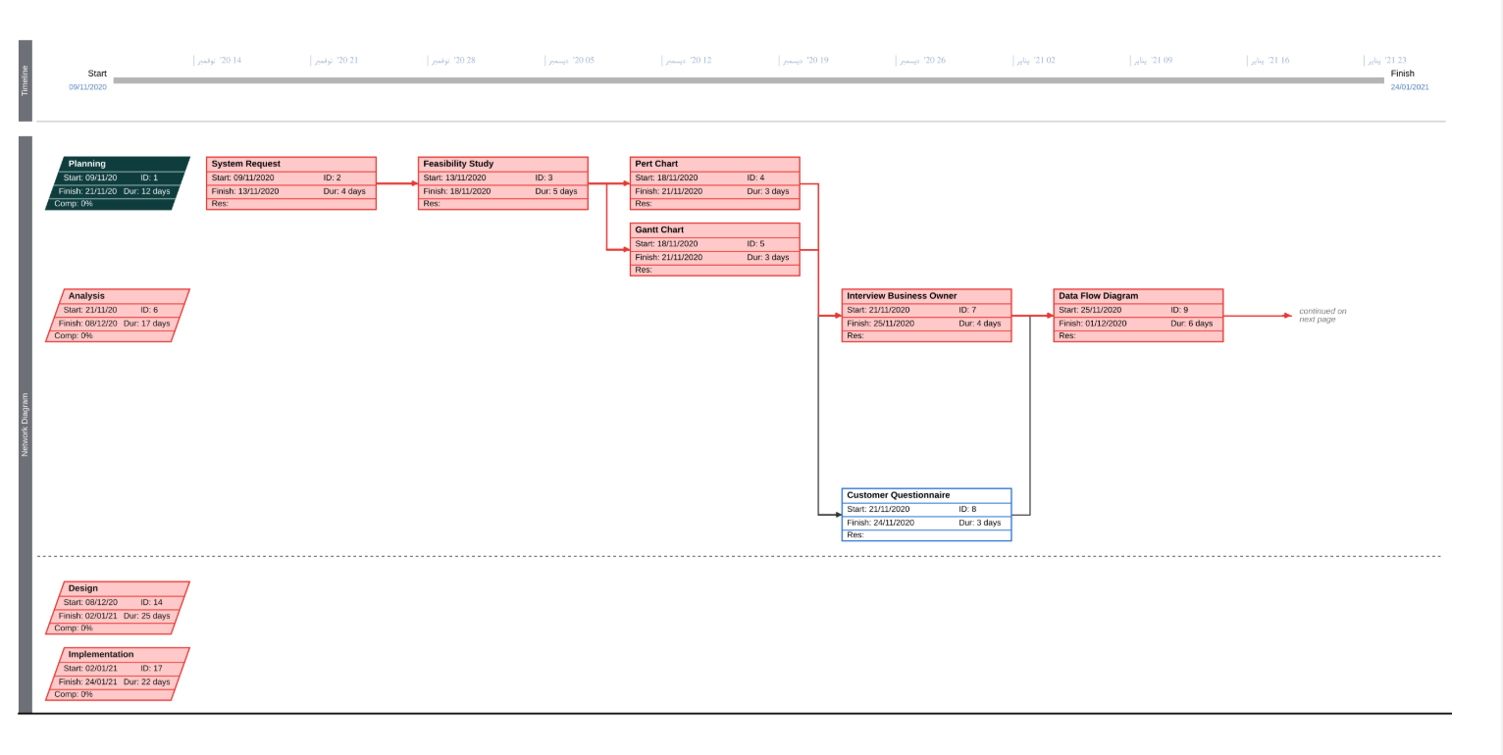
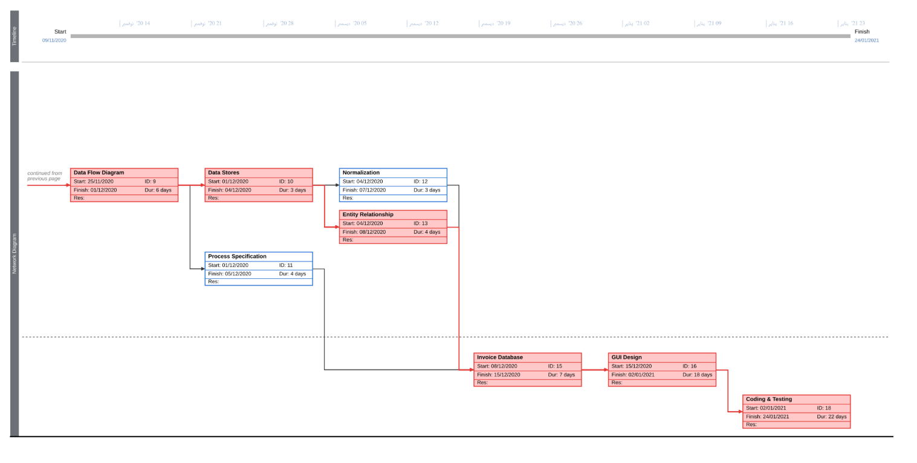

Gantt chart (MS-Project)

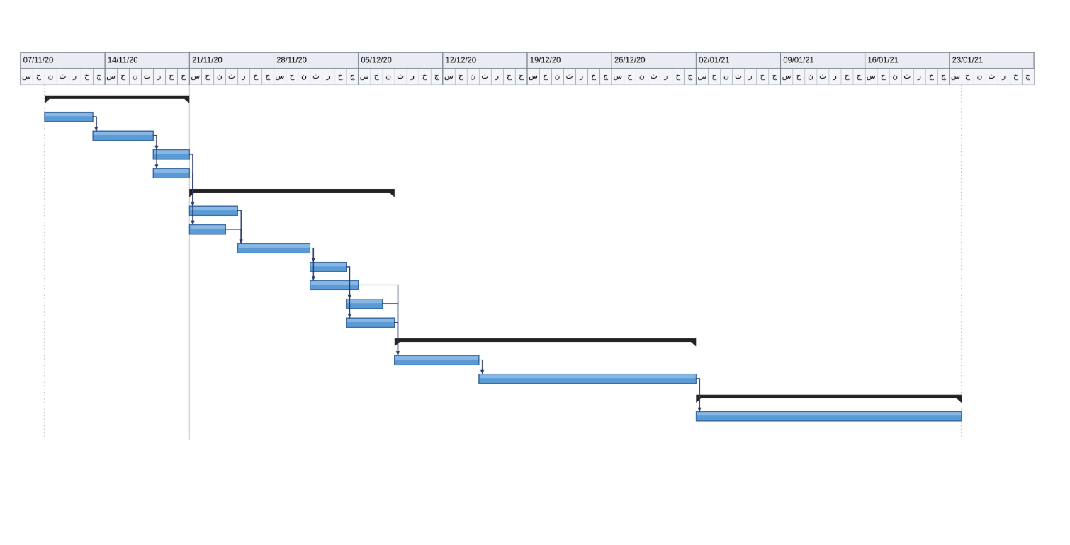

Analysis (Project Proposal)

Interview
(include questions and answers)
What is your opinion of the current invoice tracking system?
I think it is difficult to manage invoices and payments manually.
2. Is the current system easy to use?
No, it takes time to find invoices and check their payment status.
3. How does the current system work?
Invoices and payments are recorded manually or in Excel sheets, and the business owner checks them when needed.
4. What are the common problems in the current system?
Missing invoices, incorrect payment records, and forgetting payment deadlines.
5. What are the main objectives of the new system?
To organize invoices, track payments, save time, and reduce errors.
6. What tools do you use in the current system?
We use paper records or Excel sheets.
7. What features would you like to add to the new system?
I would like to add invoices, record payments, and view unpaid or overdue invoices.
8. Can the current system help you find unpaid invoices easily?
No, it can be difficult to identify them quickly.
9. Would automatic payment reminders be useful?
Yes, they would help us remember payment deadlines.
10. Do you have anything else to add?
No, thank you.

Interview Reports
Interview Report
Person Interviewed: Arafaa
Interviewer: Marawan
Purpose of Interview:
- To understand how invoices and payments are currently managed.
- To identify problems in tracking unpaid invoices.
- To know what features are needed in the new system.
Summary of Interview:
- The business records invoices and payments manually or using Excel sheets.
- It is difficult to find unpaid invoices and remember payment deadlines.
- The new system should organize invoices and track payment status.
Open Items:
- Add reminders for overdue invoices.
- Make invoice information easy to search.
- Reduce errors in payment records.
Detailed Notes: See attached interview questions and answers.

Interview Report
Person Interviewed: Mahmoud
Interviewer: Ameer
Purpose of Interview:
- To understand how payment records are maintained.
- To identify difficulties in calculating paid and unpaid amounts.
- To determine the reports needed by the business.
Summary of Interview:
- The accountant needs to check payment records regularly.
- Calculating total paid and unpaid amounts manually takes time.
- The new system should record payments and calculate balances automatically.
Open Items:
- Add a feature to calculate outstanding balances.
- Provide reports for paid and unpaid invoices.
- Allow users to update payment records.
Detailed Notes: See attached interview questions and answers.

Interview Report
Person Interviewed: Youssef
Interviewer: Arafaa
Purpose of Interview:
- To understand how employees create and update invoices.
- To identify problems when searching for invoice information.
- To learn how the system can be made easier to use.
Summary of Interview:
- Employees need to find invoices by invoice number or customer name.
- Searching through paper records or spreadsheets can take time.
- The new system should have a simple interface and organized invoice information.
Open Items:
- Add invoice search by number or customer name.
- Make the system easy to use.
- Protect invoice and payment information.
Detailed Notes: See attached interview questions and answers.

Questionnaire & RESPONSES
(using Google Forms, you must include questions and statistics)

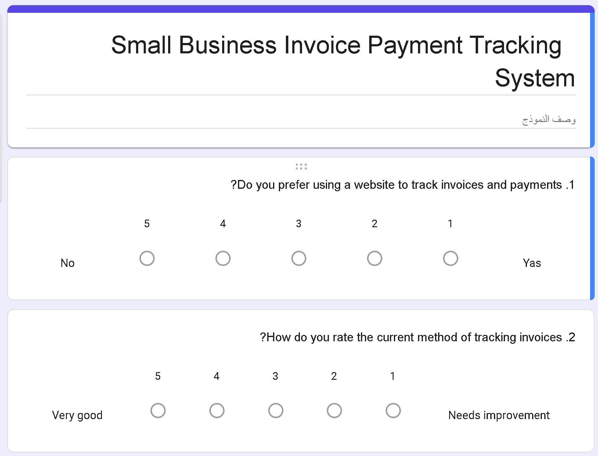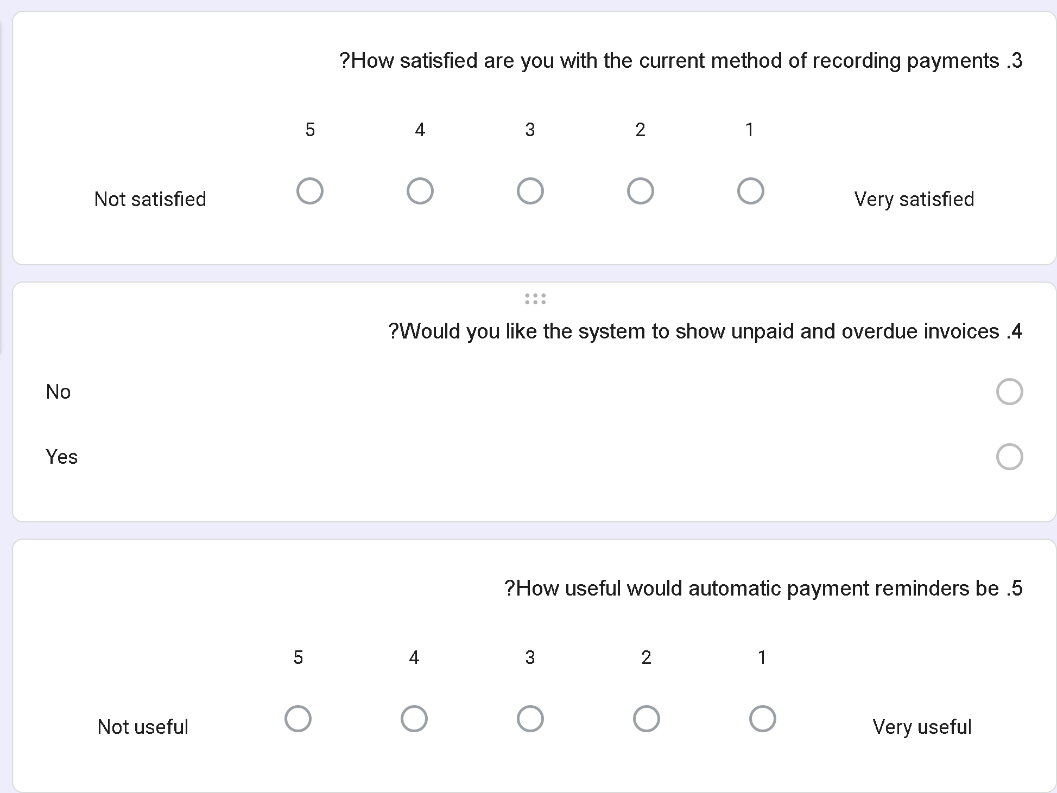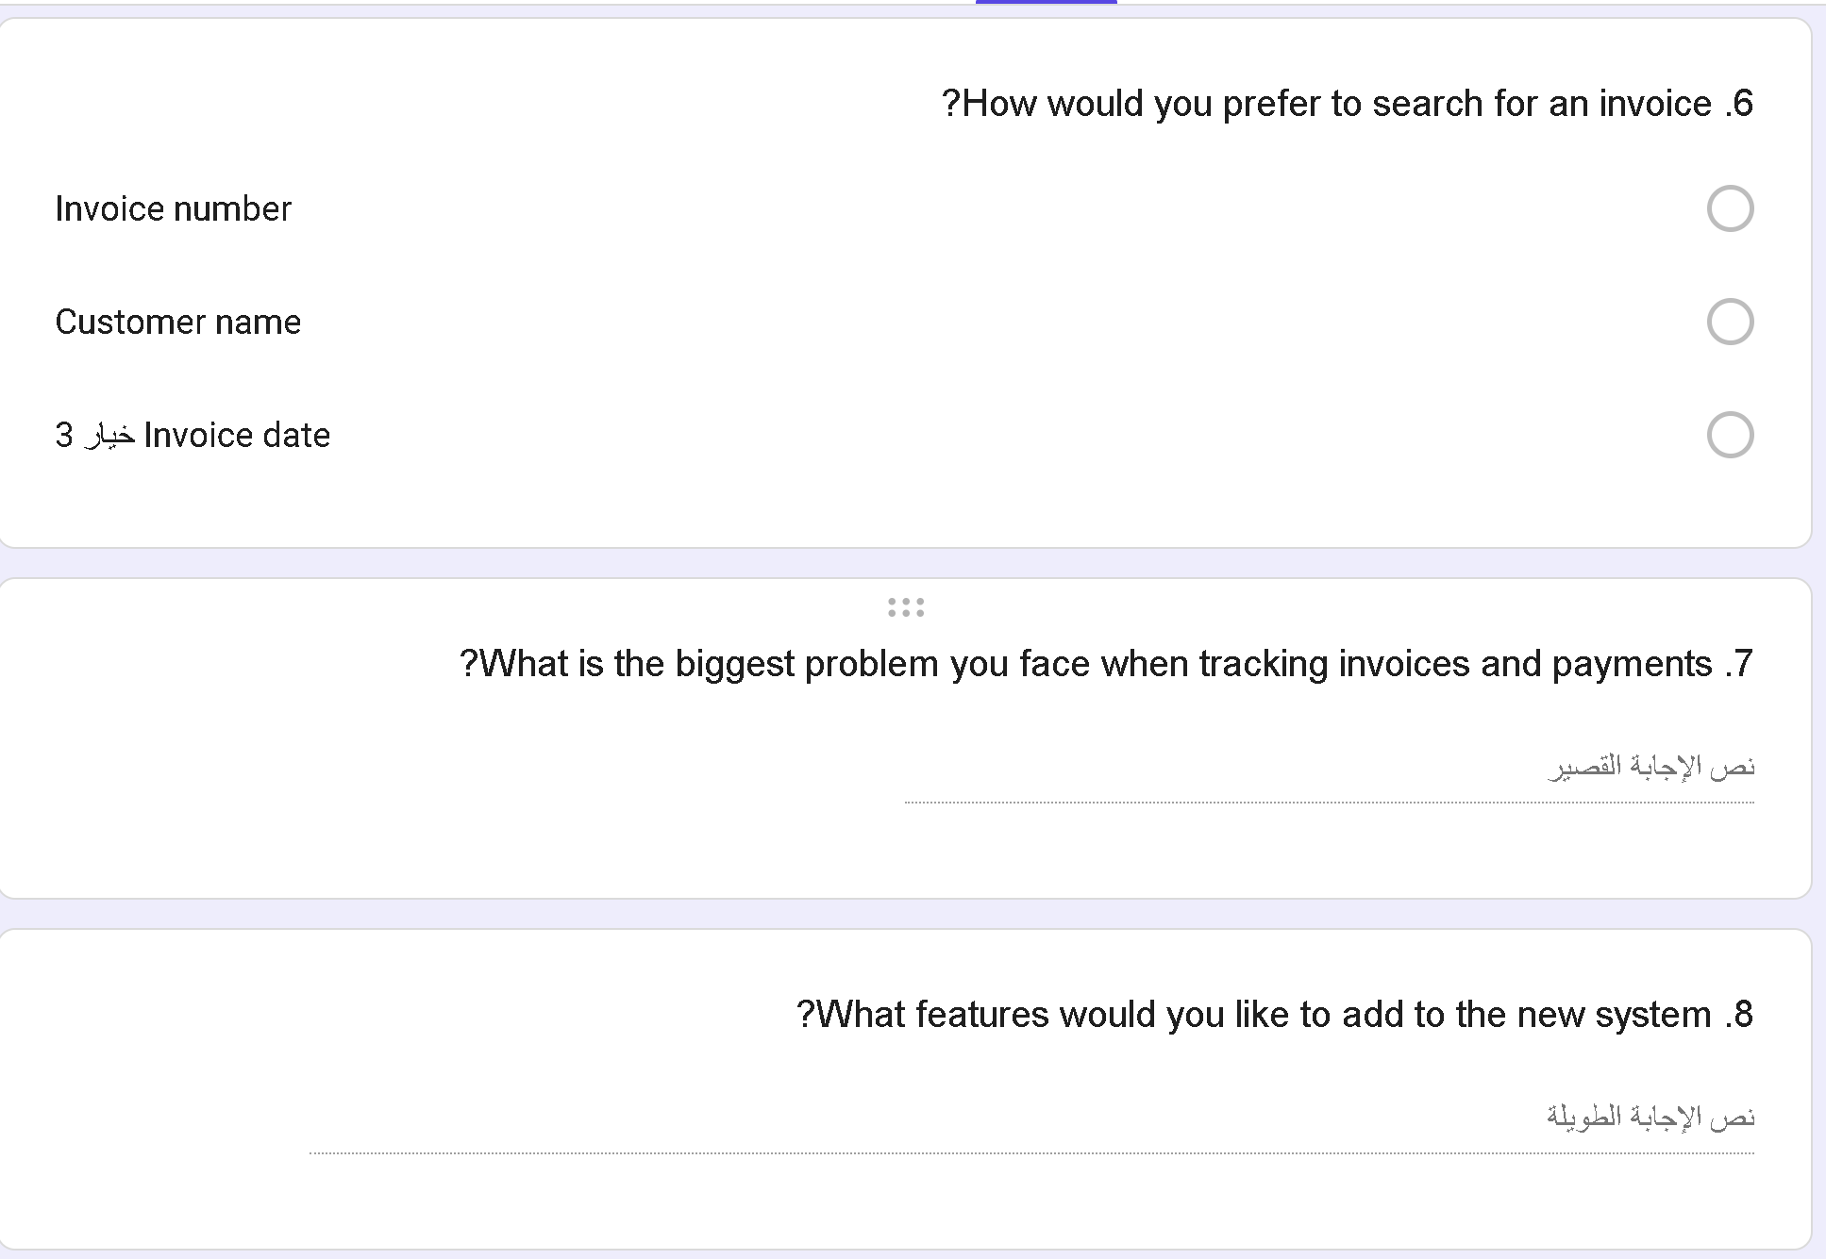
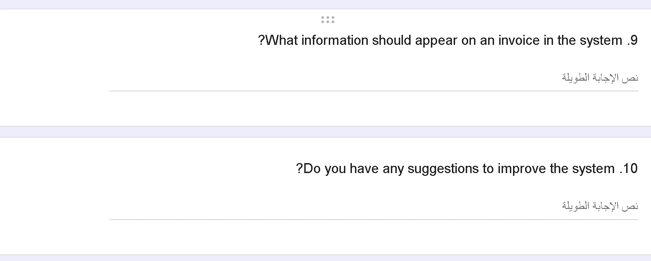

Data Flow Diagram - Context Diagram

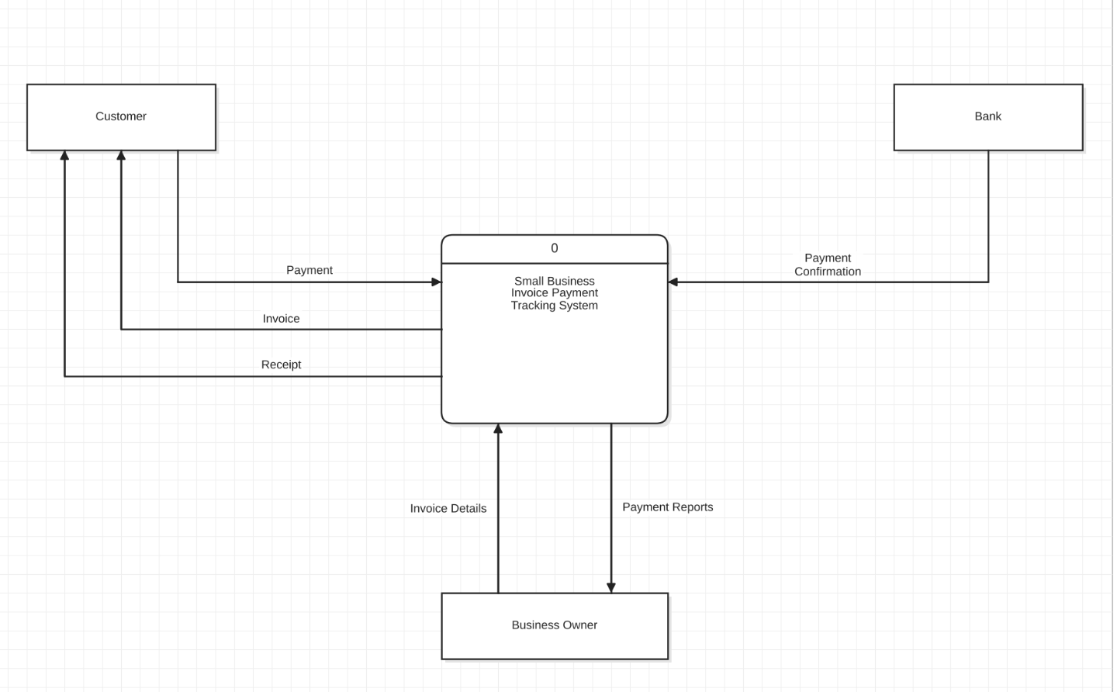

Data Flow Diagram – Level/Diagram 0

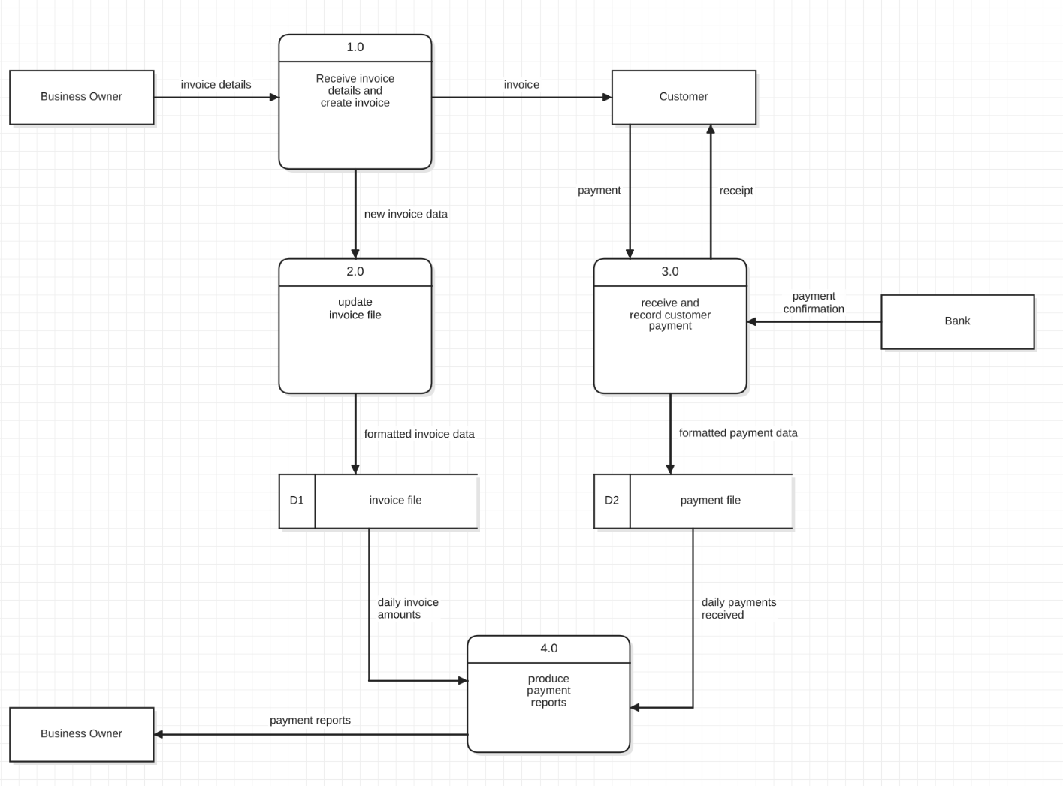

Data Flow Diagram – Level 1



